Program Features: Looping structure, variables, data input and output, mathematical operators, function calls.

The German mathematician Gottfried Wilhelm von Leibniz used the following infinite series of numbers in an early calculation of an approximate value for the transcendental number Pi:

$$π=\sum_{k=0}^{∞}{{\left(-1\right)}^{k}\left( \frac{4}{2k+1} \right)}$$

Use a FOR loop to make a C++ program that uses Leibniz’s series to calculate and display an approximate value for Pi by keeping a finite number of terms, $N$. This truncated series approximation for Pi has the formula

$$π≅\sum_{k=0}^{N}{{\left(-1\right)}^{k}\left( \frac{4}{2k+1} \right)}$$

Use double-precision floating-point numbers in performing the calculations.

Use a FOR loop to calculate an approximation of Pi for $N=0$, $N=1$ ... to $N=15$. Find the $\% error$ for each value of $N$, according to the formula

$$\% error= \frac{(approximate value of π-actual value of π)×100}{actual value of π}$$

For the actual value of Pi, use the value found from

double const PI = 4*atan(1);

After each calculation display $N$, the approximated value of Pi, the actual value of Pi and the $\% error$ on the screen. The first few lines in the output should look something like the following illustration.

Student Name
ECE 2305
Programming Project 03

Leibniz Series Approximation of Pi

N Approximate Value Actual Value % Error
0 4.00000000000 3.14159265359 27.3239544735
1 2.66666666667 3.14159265359 - 15.1173636842

The first column is the value of $N$, the second column is the approximate value of Pi, the third column is the actual value of Pi and the fourth column is the $\% error$.

Set the number of decimal points that are shown in the display with the following code. These line should be executed only once.

cout.setf(ios::fixed);
cout.setf(ios::showpoint);
cout.precision(15)

To document your work, create a Word document. Include the following material in the document.

A. A brief description of the purpose of the program and the structure of the program.

B. A Flowchart to illustrate the structure of the program.

C. The code listing of the program.

D. A screen capture of the output of the program

Save the Word document as a PDF file and submit the PDF document on Blackboard.

- This program evaluates a series approximation for the number pi and compares the approximation to an accurate value of pi. The program uses nested for loops to accumulate a sum.

- Flowchart of the Program:
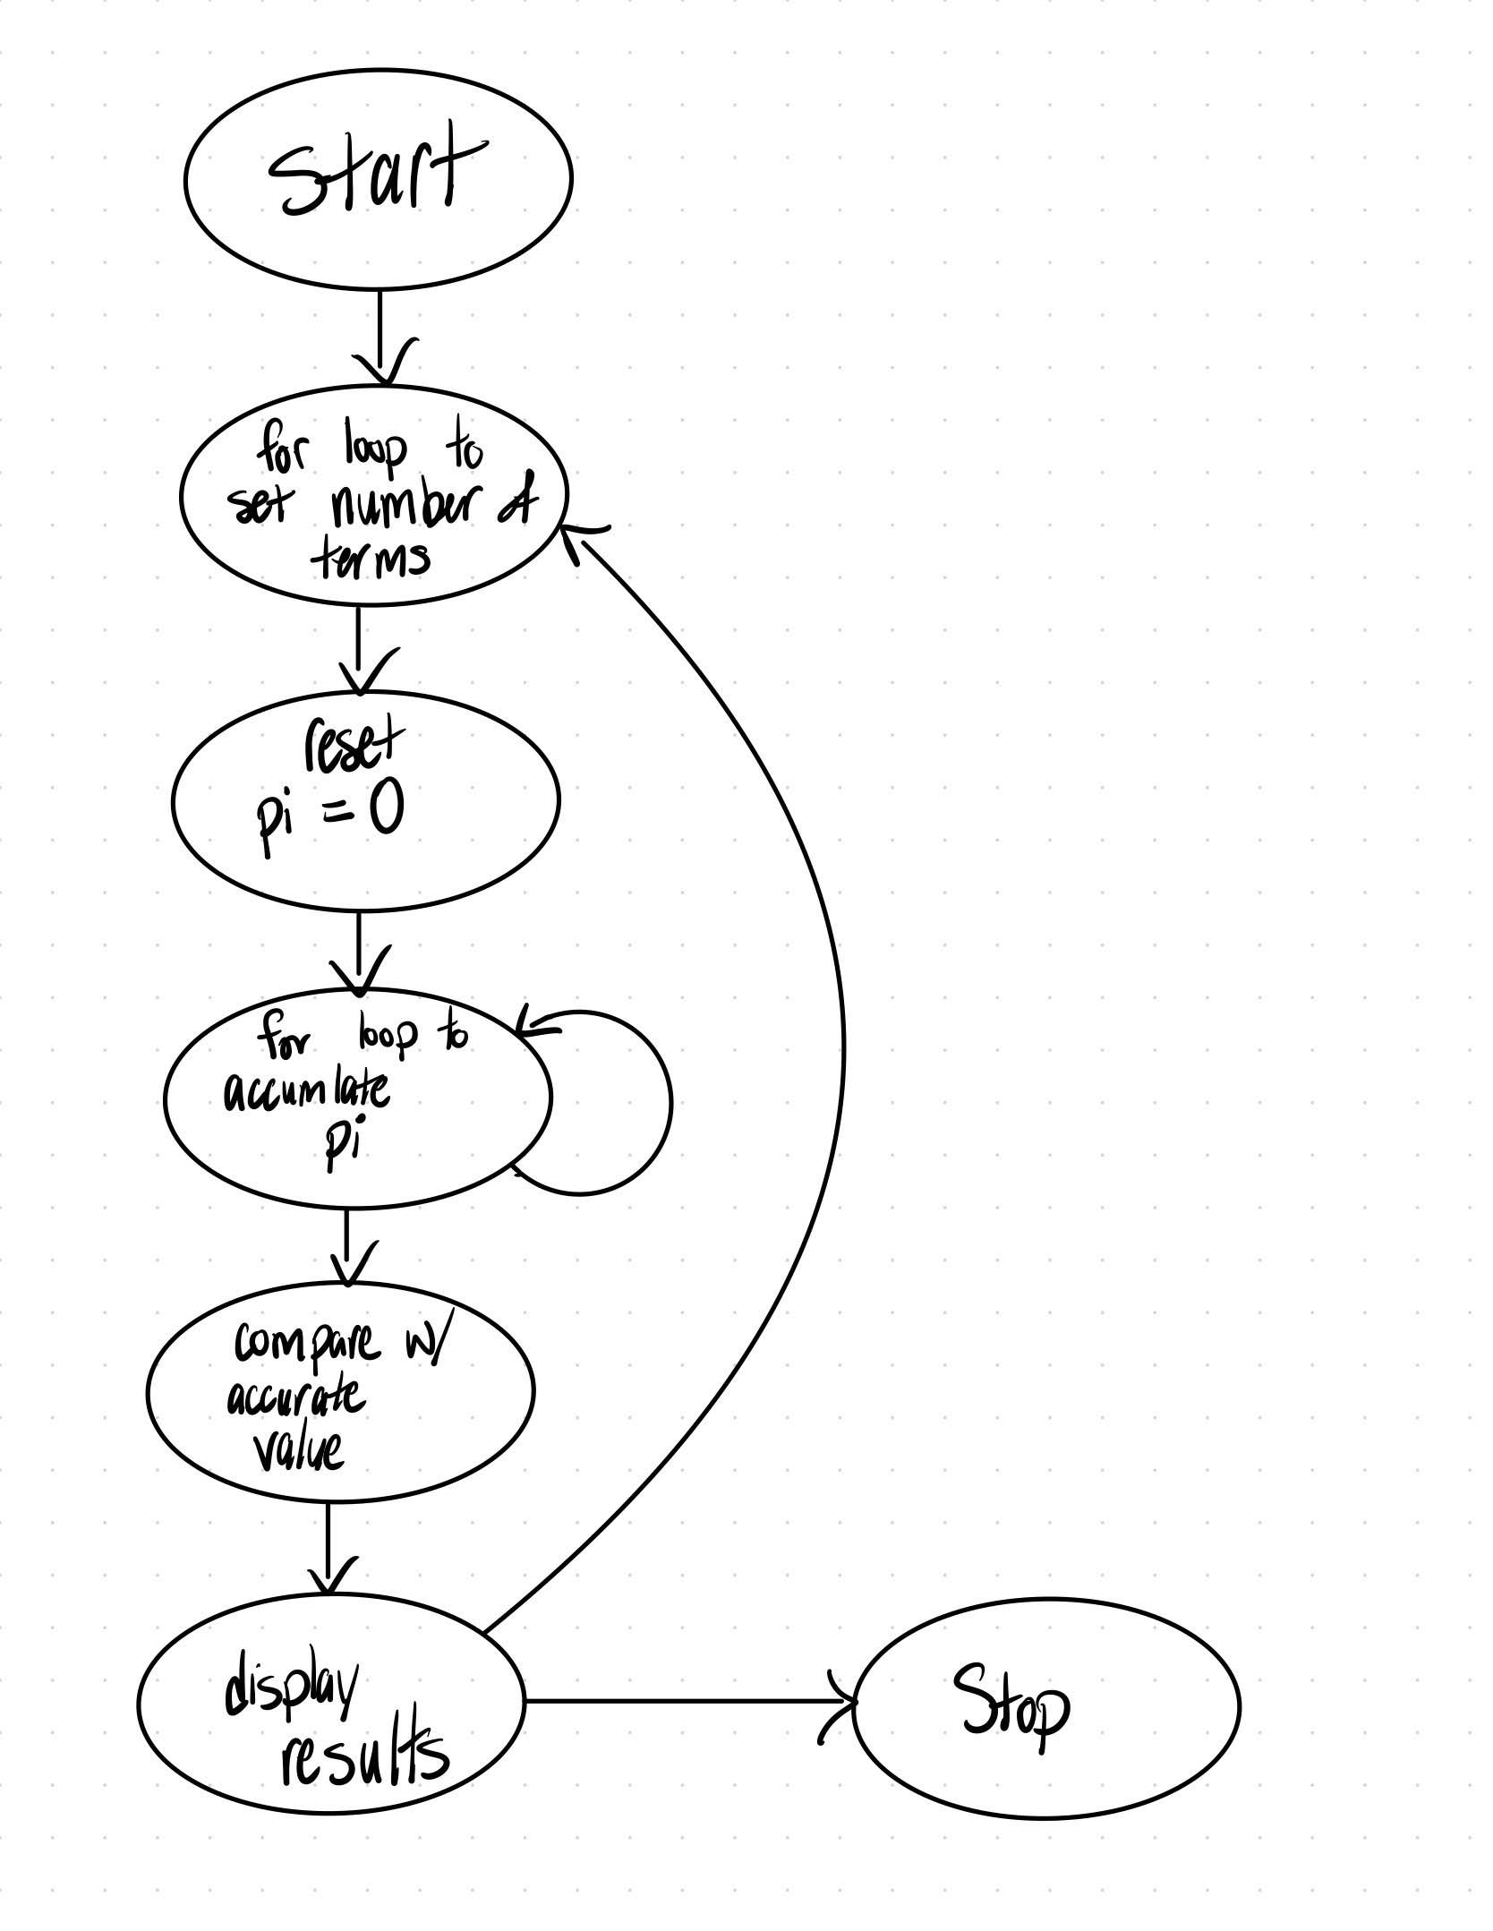
- Code Listing:
// ECE 2305 - Programming Project 03
#include <iostream>
#include <cmath>
using namespace std;

double calculatePi(int terms) {
double pi = 0;
for (int k = 0; k <= terms; k++) {
pi += pow(-1, k) * 4.0 / (2 * k + 1);
}
return pi;
}

int main() {
const double ACTUAL_PI = 4 * atan(1);
cout.setf(ios::fixed);
cout.setf(ios::showpoint);
cout.precision(15);

cout << "------------------------------------------------------------\n";
cout << "N\tApprox. Pi\t\tActual Pi\t\t% Error\n";

for (int N = 0; N <= 15; N++) {
double approxPi = calculatePi(N);
double error = ((approxPi - ACTUAL_PI) / ACTUAL_PI) * 100;

cout << N << "\t" << approxPi << "\t" << ACTUAL_PI << "\t" << error << "%\n";
}

system("pause");
return 0;
}

- Program Output:
